|  |
| --- |
| By: Farid Javadnejad |

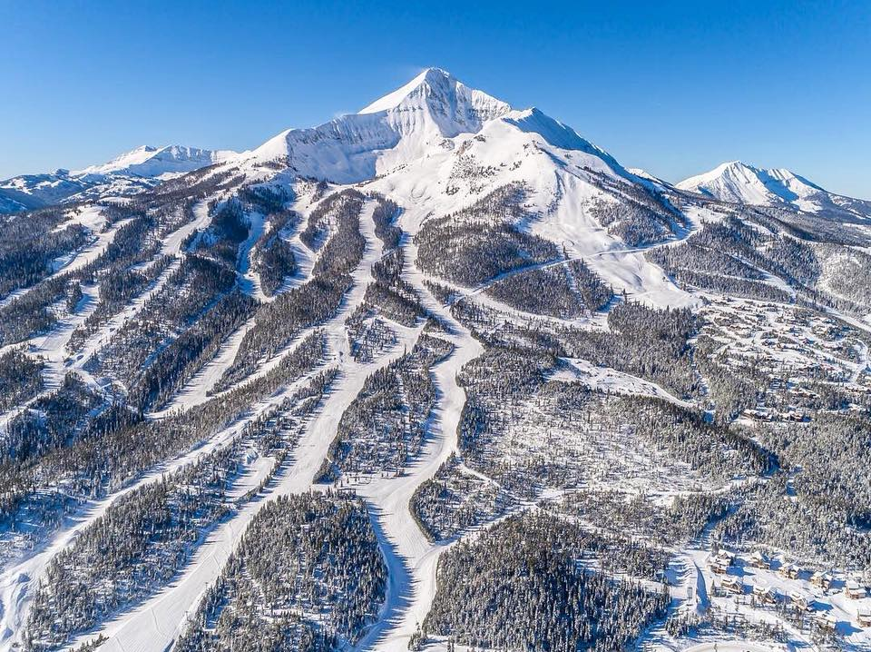

|  |
| --- |
| New Ticket Price Estimation |
| Using Data Science Methods for Big Mountain Ski Resort |
| **Springboard Data Science Track, 2022** |

|  |
| --- |
| New Ticket Price Estimation |
| Using Data Science Methods for Big Mountain Ski Resort |
| Executive Summary Big Mountain Resort is a ski resort located in Montana serving nearly 350,000 skiers every year. The resort has recently installed a new chair lift to help increase the distribution of visitors across the mountain, which will result in additional operating costs of $1.540M this season. The resort needs to adjust its finances to accommodate the cost of the new facility by increasing the price of their tickets or by cutting other costs of their facility. The objective if this study is to set a pricing strategy to ensure covering the additional operational cost for the season, or identifying the areas to cut the cost. To achieve this a competitive analysis against the 300 ski resorts in the country was conducted to identify the direct competition to set an average price strategy. The important features were identified, analysed and used to build ordinary regression and random forest regression models that can predict the price for a Big Mountain Resort based on given features. This study suggests a new ticket price of $94 compared to the current price of $81. The new price 1) is supported by the data science methods, 2) is comparable to the competition and 3) ensures the business revenue. Data We collected important operational and business-related information that may impact the ticket price, together with ticket prices for 330 ski resorts across the US; from which we selected 277 resort that included all features of interest. We also combined the resort specific data with state features to create a total of 32 numerical features can be used to model the ticket prices. Model We build linear regression and random forest regression models to predict the dependent ticket price feature using the numerical independent features. We split the data to train and test sets, and used it in an automated pipeline of cross-validation and hype-parametrization techniques to build the model with best performance with respect to test core metrics. Our random forest model had the best performance for estimating the ticket prices for the provided data, with Train MAE of 9.6550 ± 1.4779 and Test MAE of 9.4338. |

Using the best performance model, we also studied a number of business scenarios, including: 1) closure of a number of least used runs, 2) adding one run to increase the vertical drop by 150 feet, and installing a chair lift to support it, 3) adding 2 acres of snow making to the third scenario 4) increasing the longest run by 0.2 miles and adding 4 acers of snow making capacity.

## Results

Our modelled price suggests the new price of $94.26, while Big Mountain resort currently charges $81 for adult ticket in the weekends. The modelled price is supported by the facilities that Big Mountain provides in the market place. In national scale, Big Mountain is already one of the most expensive resorts (Fig 1.a); however, the $13 increase in ticket price will not dramatically change its position in the in the league (Fig 1.a). Big Mountain is one of countries top resorts with large snow making area (Fig 1.b), skiable terrain (Fig 1.c), number of fast quads (Fig 1.d), longest runs (Fig 1.e), and vertical drop (Fig 1.f).

|  |  |  |
| --- | --- | --- |
|  |  |  |
| (a) | (b) | (c) |
|  |  |  |
| (d) | (e) | (f) |

Fig 1. A number of key features in ski resorts and the position of Big Mountain; a) current and modelled weekend ticket price, b) area covered by snow makers, c) skiable train area, d) number of fast quads, e) longest run length, and f) vertical drop.

From the tested scenarios, the scenario 1 that included closing the least used runs may reduce the maintenance cost of the resort. The scenario 2 has the biggest finical improvement that can increase the support for ticket price by $1.70 with revenue growth of $2.967M.

### Conclusion

The additional operating cost of the new chair lift is $1.54M in the season. This means the ticket price needs to rise at least $4.4 to $85.4 in order to cover the operating cost. The 2nd scenario to add a run, increase the vertical drop by 150 feet, and install an additional chair lift, support for ticket price by $1.70.

Over the season, this could be expected to amount to $2.967M. The new revenue is larger than the new operational cost. It is suggested to close 1 run as doesn’t impact the ticket price or revenue; however, it will help to reduce the maintenance costs. The run closure can be tested in a pilot stage for a span of 3 weeks to review the customer feedback.

### Further work

To improve our model, it is recommended to enrich the data by having additional information such as, number of visitors per season at each resort, number of users per unit or facility in each resort, customer rating on facility quality, and survey on customer readiness to pay higher price. The only price data in our dataset were ticket prices and the information about the additional operating cost of the new chair lift, however, having detailed cost information such as cost of increasing the vertical drop by 150 feet, and cost of maintenance per run will be useful.